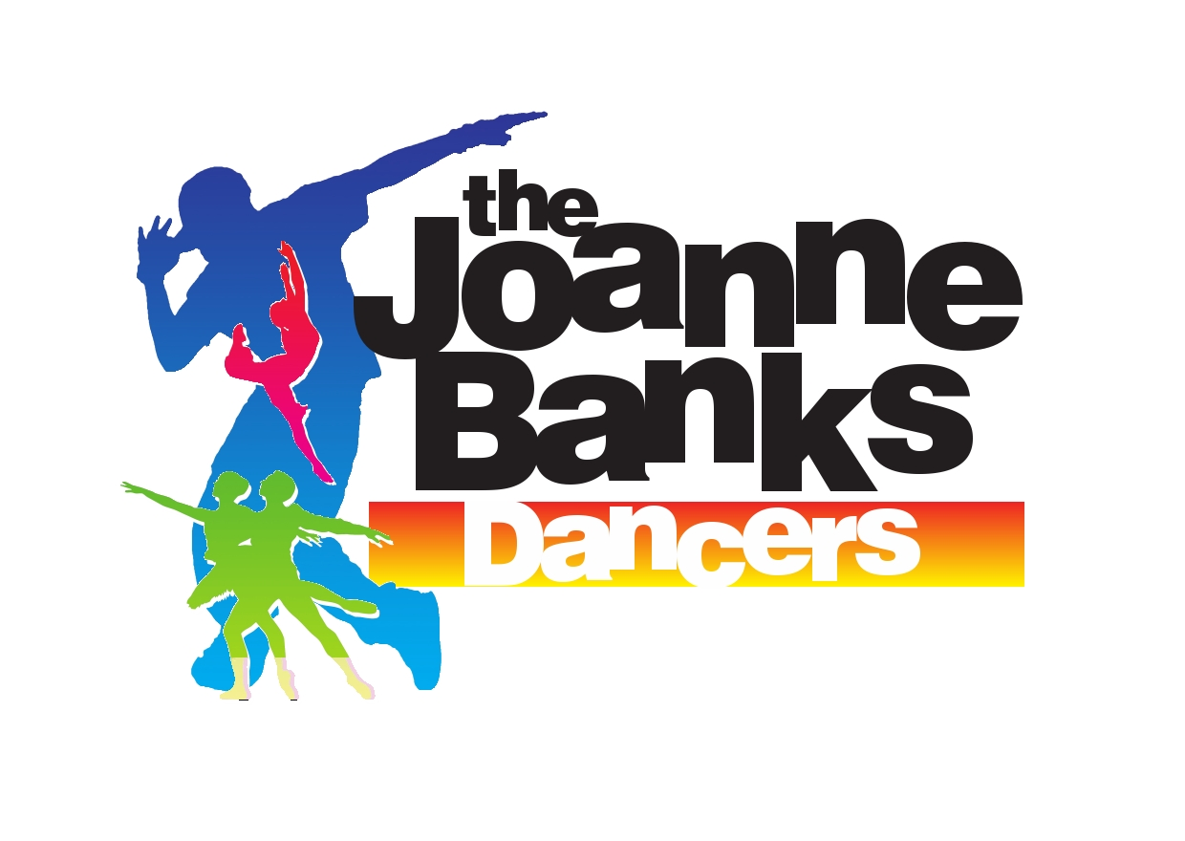
Studio 10 Live Interactive Class
Timetable March 2020

Monday
Dance Studio 1 |  | Teacher
16:30 – 17:15 | 1st Infant Tap & Modern | 16:30 – 17:15 | Jasmin Brown
17:15 – 18:00 | Baby/Infant/Junior Ballet | 17:15 – 18:00 | Jasmin Brown
18:00 – 19:00 | 1st Junior Tap & Modern | 18:00 – 19:00 | Kay Clarey
19:00 – 19:45 | 2nd Intermediate Modern | 19:00 – 19:45 | Kay Clarey
19:45 – 20:30 | Graduate Gymnastic Dance | 19:45 – 20:30 | Jasmin Brown
20:30 – 21:15 | Graduate Modern | 20:30 – 21:15 | Kay Clarey
21:15 – 22:00 | Graduate Performers | 21:15 – 22:00 | Kay Clarey
Tuesday
Dance Studio 1 |  | Teacher
15:45 – 16:30 | Boys Only | 15:45 – 16:30 | Jasmin Brown
16:30 – 17:15 | 2nd Intermediate Ballet | 16:30 – 17:15 | Jasmin Brown
17:15 – 18:00 | 2nd Intermediate Tap | 17:15 – 18:00 | Kay Clarey
18:00 – 18:45 | 1st Intermediate Ballet | 18:00 – 18:45 | Jasmin Brown
19:00 – 19:45 | 1st Intermediate Tap | 19:00 – 19:45 | Kay Clarey
19:45 – 20:30 | Senior Ballet | 19:45 – 20:30 | Kay Clarey
20:30 – 21:15 | Senior Tap | 20:30 – 21:15 | Kay Clarey
Wednesday
Dance Studio 1 |  | Teacher
15:30 – 16:15 | Infant Pop Dance | 15:30 – 16:15 | Jasmin Brown
16:15 – 17:00 | Junior Gymnastic Dance | 16:15 – 17:00 | Kay Clarey
17:00 – 17:45 | Junior Pop Dance | 17:00 – 17:45 | Jasmin Brown
17:45 – 18:30 | Intermediate Pop Dance | 17:45 – 18:30 | Joanne Banks
18:30 – 19:30 | Intermediate Musical Theatre | 18:30 – 19:15 | Jasmin Brown
19:30 – 20:30 | Senior Musical Theatre | 20:00 – 20:30 | Jasmin Brown
20:30 – 21:15 | Graduate Ballet | 20:45 – 21:15 | Kay Clarey
21:15 – 22:00 | Graduate Tap | 21:15 – 22:00 | Kay Clarey
Thursday
Dance Studio 1 |  | Dance Studio 2
16:15 – 17:15 | 2nd Juniors Tap & Modern | 16:15 – 17:15 | Kay Clarey
17:15 – 18:00 | Infant/Junior Musical Theatre | 17:15 – 18:00 | Jasmin Brown
18:00 – 18:45 | Intermediate Gymnastic Dance | 18:00 – 18:45 | Kay Clarey
18:45 – 19:30 | 1st Intermediate Modern | 18:45 – 19:30 | Joanne Banks
19:45 – 20:30 | Senior Pop Dance | 19:45 – 20:30 | Kay Clarey
20:30 – 21:15 | Senior Modern | 20:30 – 21:15 | Kay Clarey
Sunday
Dance Studio 1 |  | Dance Studio 2
10:00 – 10:45 | Twirly Tots | 10:00 – 10:45 | Jasmin Brown
10:45 – 11:30 | 2nd Infants Tap and Modern | 10:45 – 11.30 | Jasmin Brown
11:30 – 12:15 | Little Wigglers | 11:30 – 12:15 | Jasmin Brown

Please log on at least 10 minutes before your class is due to begin – your teacher will allow you entry to the online class at the start time.
Please call 01388 420210 if you have problems with the online classes.

